Exercise 4: Land Cover and Land Use Change
In this exercise, you will detect land cover and land use change (LCLUC) over the city of Fairbanks and its surrounding areas, in Alaska using ArcGIS Pro. In this exercise, you will specifically compare two existing land cover and land use data between 1984 to 2014 and identify how land cover and land use (LCLU) changed over the last 30 years.
Topics covered in this exercise include:
- Understand land cover and land use data
- Use Raster Calculator to detect broad LCLUC
- Use Compute Change Raster to detect detailed LCLUC
- Use Reclassify to the group class and improve the interpretation of LCLUC
- Use Tabulate Area to generate change matrix

Data
This project contains two raster layer: ABoVE_LandCover_10_Bh06v05_1984.tif and ABoVE_LandCover_10_Bh06v05_2014.tif, representing land cover and land use in the city of Fairbanks, and its surrounding area in Alaska, US in 1984 and 2014, respectively. The data was downloaded from the NASA ABoVE program. Download Exercise_4.zip. Save it in the location you are choosing and unzip it by right-clicking on Exercise_4.zip. In the drop-down window, choose “Extract All”.

Step 1. Create a Project in ArcGIS Pro

- In the search bar at the left corner, type “ArcGIS Pro”. You will see the software “ArcGIS Pro”. Click on it, the ArcGIS Pro will be loaded.
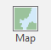
Note, this can also be done by navigating to All Apps followed by the ArcGIS Folder. Within the ArcGIS Folder, select ArcGIS Pro.
- Create a project to host your maps by clicking on the Map icon.
- The Create a New Project window should be shown. Define the name for your project. You can give any name that you prefer. Then click on Folder icon, find the location where you want to save your project.
- You do not need to change others.
- Click on OK.

Step 2. Understand the LCLU data

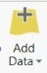
You will first add ABoVE_LandCover_10_Bh06v05_1984.tif and ABoVE_LandCover_10_Bh06v05_2014.tif layers to the map within your project.
- Click the Add Data button. This button is available under the Map Tab within the Layer Section.
- Navigate to your directory that stores the data. Specifically, navigate to the Exercise_4 folder.

Within the folder, select ABoVE_LandCover_10_Bh06v05_1984.tif and ABoVE_LandCover_10_Bh06v05_2014.tif. Click OK to add them to the map. The maps are shown on a grey scale.

You will now symbolize them using the same color scheme.
- Right-click on ABoVE_LandCover_10_Bh06v05_1984.tif layer in the Contents Pane, in the drop-down menu, select Symbology.
- In the Symbology window, set Primary symbology to “Unique Values”. If it asked whether to build an attribute table, select Yes.
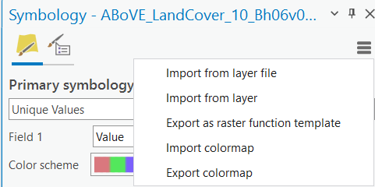
- Set Field 1 to “Value”. Select your favorite color scheme. You will see that there are 10 classes with unique colors.
- To visually compare the two maps, you will use the same color scheme to symbolize the 2014 map. Click on the expansion icon under the Symbology window, in the drop-down menu, select “Export colormap”. Highlight the location you want to save the colormap and give the name of the file as “1984_colormap.clr”. Click on Save.
- You do not need to change others.

Now you will use the color scheme from the 1984 map to symbolize the 2014 map.
- Right-click on ABoVE_LandCover_10_Bh06v05_2014.tif layer in the Contents Pane, in the drop-down menu, select Symbology.
- In the Symbology window, set Primary symbology to “Unique Values”. If it asked whether to build an attribute table, select Yes.
- Set Field 1 to “Value”.
- Click on the expansion icon, in the drop-down menu, select Import colormap. Navigate the location where you saved 1984_colormap.clr, highlight it and click on OK.
- You do not need to change others.

The two maps now should have the same colors for each class. Turn on/off the two layers in the Content Pane, answer the following question.

Question 1. By visual assessment, was there land cover and land use change between 1984 and 2014? How did you observe that? (4 Points)

You may have noticed there are 10 classes in the two maps, from number 1 to 10. These numbers are actually place-holder, representing different land cover and land use types, as shown in Table 1.

Table 1 Land cover classes.
ID | Label
1 | Evergreen Forest
2 | Deciduous Forest
3 | Shrubland
4 | Herbaceous
5 | Sparsely Vegetated
6 | Barren
7 | Fen
8 | Bog
9 | Shallows/Littoral
10 | Water

Open the attribute of the two maps, answer the following questions. You can open the attribute table by right-clicking on the map, in the drop-down menu, select Attribute Table.

Question 2. Which class was dominant in the 1984 map? How about in the 2014 map? (4 Points)

Question 3. Which class was the least in the 1984 map? How about in the 2014 map? (4 Points)

Step 3. Detect LCLUC using Raster Calculator

Now you are ready to detect LCLUC. You will first subtract the 1984 map from the 2014 map to identify the changes.

- Navigate to Analysis Tab, click on Tools.
- In the Geoprocessing window, expand Spatial Analyst Tools, followed by Map Algebra.
- Click on Raster Calculator.
- In the Raster Calculator window, put the "ABoVE_LandCover_10_Bh06v05_2014.tif" - "ABoVE_LandCover_10_Bh06v05_1984.tif" in the calculation box.
- Set Output Raster as “LCLUC_RastCal”.
- You do not need to change others.
- Click on Run.
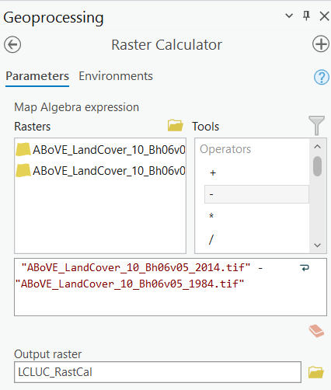

The LCLUC_RastCal should be automatically loaded in the Contents Pane.

If the land cover and land use types changed during the two-time period for a pixel, the place-holder numbers for that pixel should be different in the two-time period. If the land cover and land use types did not change, the place-holder numbers for that pixel should be the same. As such, the value of 0 represents that there are no LCLU changes between 1984 and 2014, while other values represent there are changes.

Based on the attribute table of LCLUC_RastCal layer, answer the following question.

Question 4. Which value was dominant in the change map? (4 Points)

You will now reclassify the map to generate a binary map with the value of 0 representing no change and the value of 1 representing change.

- Navigate to Analysis Tab, click on Tools.
- In the Geoprocessing window, expand Spatial Analyst Tools, followed by Reclass.
- Click on Reclassify.
- In the Reclassify window, set Input raster as “LCLUC_RstCal”, and Reclass field as “Value”.
- In the Reclassification box, reclassify every non-zero value to 1, zero to 0, and keep NODATA as NODATA.
- Set Output raster as LCLUC_RastCal_re.
- You do not change others.
- Click on Run.
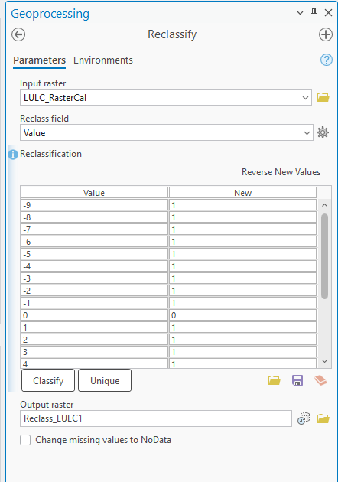

Deliverable 1. Screenshot your map showing the changed and unchanged land cover and land use. (2 Points)
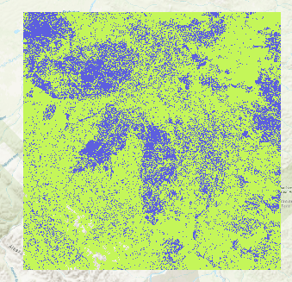
Use the map to answer the following question.

Question 5. Which part experienced land cover and land use change during the last ~30 years? (4 Points) (Hint, 0 represents no change and 1 represents there were changes)

Based on the attribute table of LCLUC_RastCal_re layer, answer the following question.

Question 6. How many pixels experienced land cover and land use change? How many pixels did not change (4 Points) (Hint, 0 represents no change and 1 represents there were changes)

Step 4. Detect LCLUC using Compute Change Raster

The above change detection method could give us the changed and unchanged regions, however, it could not tell what the detailed transitions are. That is to say, it did not tell us if the pixels changed from Water to Barren or From Evergreen Forest to Shrublands. This information is very important for understanding carbon emission changes due to LCLUC. In this step, you will learn how to use Compute Change Raster to get more detailed LCLUC information.

- Navigate to Analysis Tab, click on Tools.
- In the Geoprocessing window, expand Image Analyst Tools, followed by Change Detection.
- Click on Compute Change Raster.
- In the Compute Change Raster, set From Raster to “ABoVE_LandCover_10_Bh06v05_1984.tif”, To Raster to “ABoVE_LandCover_10_Bh06v05_2014.tif”, and Output Raster to “LCLUC_detail”.
- Set Compute Change Method as “Categorical difference” and Filter Method as “Changed pixels only”.
- Click on Run.
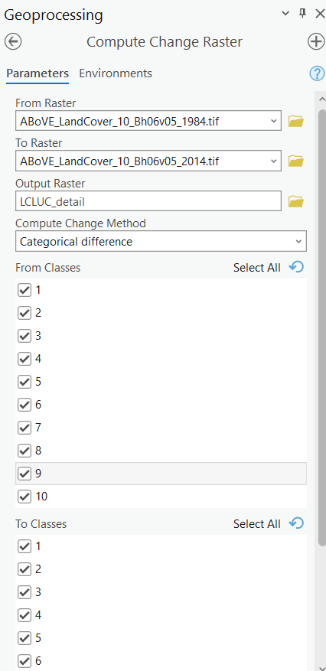

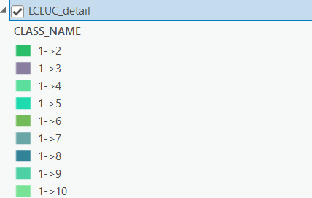
The LCLUC_detail should be automatically added to the Contents pane. To see the results clearly, turn off all other layers. Expand LCULC_detail layer in the Contents pane. A list of legend should be shown. The legend tells that the different colors represent different transitions. For instance, 1->2 represents the pixels experiencing changes from Evergreen Forest in 1984 to Deciduous Forest in 2014. Note, the meaning of place-holders can be found in Table 1.

Open the attribute table of LCLUC_detail layer, answer to following questions.

Question 7. Excepting pixels with no change, which transition was dominant? How much land experienced such a transition? Please give the class name, not the place-holders. (4 Points) (Hint, you can sort the table by right-clicking on the column, followed by Sort Descending or Sort Ascending; you can find the transitions in CLASS_NAME field and area in AREA field)

Highlight the record (i.e., row) showing the dominant transition. The pixels that experienced such a transition should be highlighted on the map.

Deliverable 2. Screenshot your map showing the dominant transition. (4 Points)
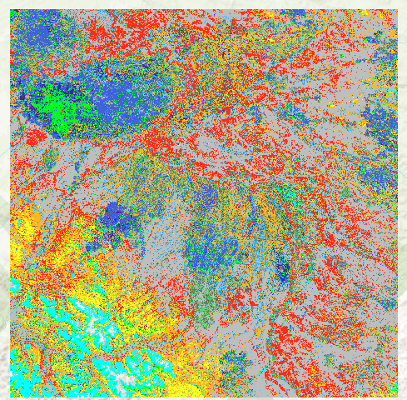

Question 8. Excepting pixels with no change, which transition was the least? How much land experienced such a transition? Please give the class name, not the place-holders. (4 Points) (Hint, you can sort the table by right-clicking on the column, followed by Sort Descending or Sort Ascending; you can find the transitions in CLASS_NAME field and area in AREA field)

Question 9. List the other four dominant transitions. Please give the class name, not the place-holders. (4 Points) (Hint, you can sort the table by right-clicking on the column, followed by Sort Descending or Sort Ascending; you can find the transitions in CLASS_NAME field)

Step 5. Reclassify LCLUC from Compute Change Raster

The LCLUC_detial provides very detailed transitions for LCLUC. Such a great number of classes makes it hard to interpret the results. One way we can reduce the class number is to reclass the classes before using the Computing Change Raster. The other way is to postprocessing the results. Both are acceptable. In this exercise, we will reclassify LCLUC results from Compute Change Raster. We will retain the dominant transitions while grouping others into Other Changes.

- Navigate to Analysis Tab, click on Tools.
- In the Geoprocessing window, expand Spatial Analyst Tools, followed by Reclass.
- Click on Reclassify.
- In the Reclassify window, set Input raster as “LCLUC_detail”, and Reclass field as “CLASS_NAME”.
- In the Reclassification box, reclassify 1->5 to 15, 1->3 to 13, 1->7 to 17, 4->3 to 43, and 2->3 to 23. Reclassify every other value to 255, representing other changes. Reclassify No Change to 254. Keep NODATA as NODATA.
- Set Output raster as LCLUC_detail_re.
- You do not change others.
- Click on Run.
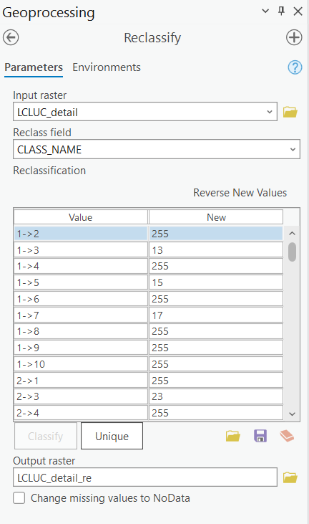

The LCLUC_detail_re should be automatically added to the Contents pane. You could see there are only seven classes now. As the legend uses place-holders, it is not straightforward to interpret. We can change it through symbology.

- Right-click on LCLUC_detail_re layer, in the drop-down menu, select Symbology.
- In the Symbology window, make sure Primary symbology is “Unique Values”, and Field 1 is “CLASS_NAME”.
- In the Values box, under the Label column, change 1->3 to Evergreen Forest to Shrubland, 1->5 to Evergreen forest to sparsely vegetated, 1->7 to Evergreen Forest to Fen, 2->3 to Deciduous Forest to Shrubland, 4->3 to Herbaceous to Shurbland, 1->2/1…-> to Other Changes.
- You can also change the Color scheme if you like.
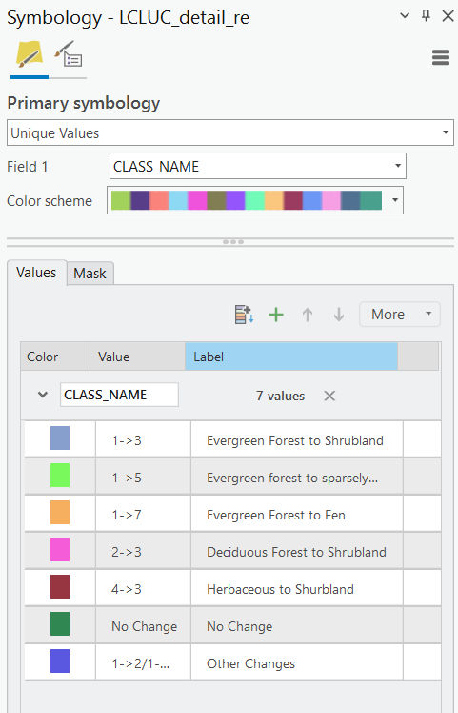

The legend should be updated.

Deliverable 3. Create a map layout for LCLUC_detail_re layer and submit your layout in PNG format. You map should include (4 points):
- A proper title
- A proper legend
- A proper North arrow
- A proper scale bar

Your layout should look like the following map.
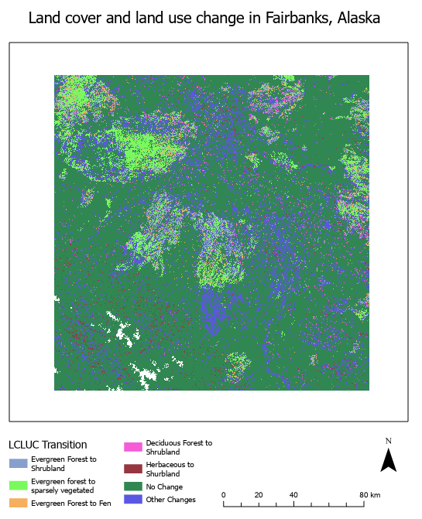

Step 6. Detect LCLUC using Tabulate Area

The above change detection methods give great spatial results. In this step, you will learn an alternative way to obtain a change matrix table from 1984 to 2014. Basically, the matrix table will tell how much was changed from one class to another.

- Navigate to Analysis Tab, click on Tools.
- In the Geoprocessing window, expand Spatial Analyst Tools, followed by Zonal.
- Click on Tabulate Area.
- In the Tabulate Area window, set Input raster or feature zone data as “ABoVE_LandCover_10_Bh06v05_1984.tif”, Zone field as “Value”, Input raster or feature class data as “ABoVE_LandCover_10_Bh06v05_2014.tif”, Class field as “Value”, and Output table as “LCLUC_table”.
- Set Processing cell size as “ABoVE_LandCover_10_Bh06v05_2014.tif”.
- You do not need to change others.
- Click on Run.
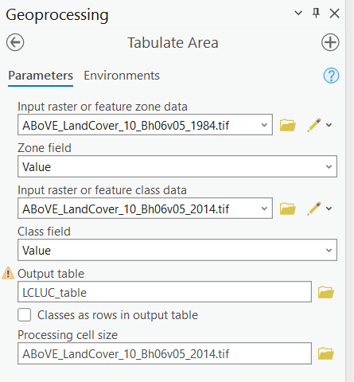

The LCLUC_table should be automatically added to the Contents pane.

- Right-click on LCLUC_table, in the drop-down menu, select Open.

In the LCLUC_table, you should find there is a field/column, named VALUE. It represents the classes from 1 to 10 in 1984. The meaning of the number can be found in Table 1. Similarly, Value_1 to Value_10 represents the classes from 1 to 10 in 2014. Based on this table, answer the following question.

Question 10. How much land changed from Shallows/Littoral (9) to Bog (8)? (4 Points)

End of Exercise

Homework
Please submit a word file with 10 questions and 3 deliverables. Please submit through Blackboard.

